## CHANDIGARH UNIVERSITY

## UNIVERSITY INSTITUTE OF ENGINEERING

**DEPARTMENT OF COMPUTER SCIENCE & ENGINEERING**



|  |  |
| --- | --- |
| **Submitted By: Submitted To:**  Vivek Kumar(21BCS8129) Jayesh Surana(E13219) | |
| **Subject Name** | Competitive Coding - II |
| **Subject Code** | 20CSP-351 |
| **Branch** | Computer Science and Engineering |
| **Semester** | 6th |

**Experiment No. - 1**

**Student Name: Vivek Kumar UID: 21BCS8129**

**Branch: BE-CSE(LEET) Section/Group: 20BCS-ST-801/B**

**Semester: 6th Date of Performance: 21/02/2023**

**Subject Name: Competitive coding - II Subject Code: 20CSP-351**

1. **Aim/Overview of the practical:**

**Find the Index of the First Occurance in a String.**

Given two strings needle and haystack, return the index of the first occurrence of needle in haystack, or -1 if needle is not part of haystack.

https://leetcode.com/problems/find-the-index-of-the-first-occurrence-in-a-string/

1. **Apparatus / Simulator Used:**

* Windows 7 or above
* Google Chrome

1. **Objective:**
   * To understand the concept of String
   * To implement the concept of Occurance Count.

**4. Code:**

class Solution {

public int strStr(String haystack, String needle) {

return haystack.contains(needle)? haystack.indexOf(needle): -1;

}

}

**5. Result/Output/Writing Summary:**

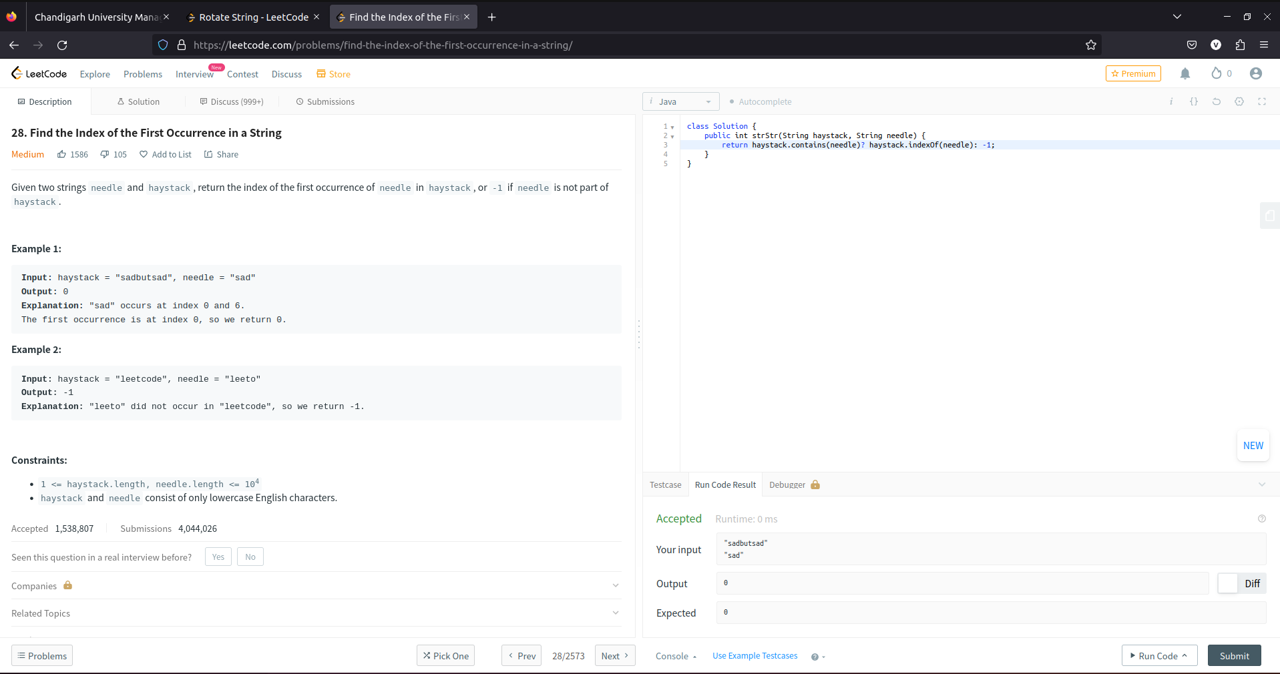

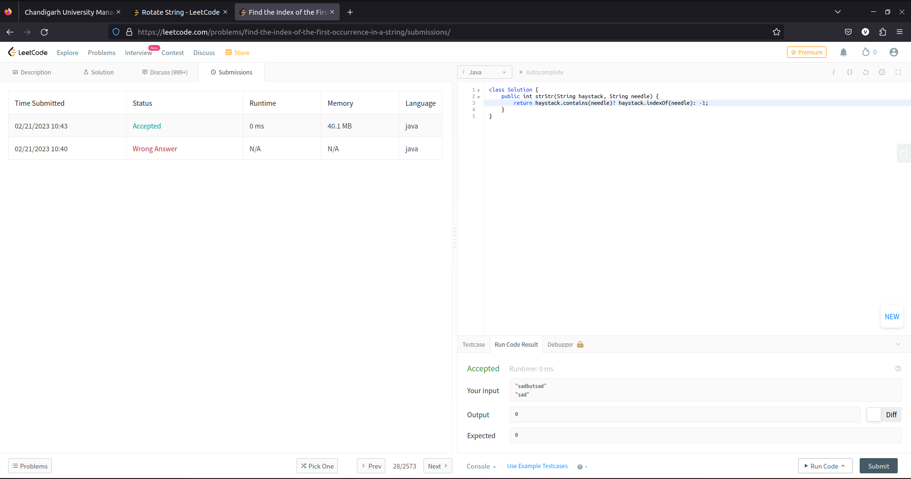

1. **Aim/Overview of the practical:**

**Rotate String**

Given two strings s and goal, return true if and only if s can become goal after some number of shifts on s.

A shift on s consists of moving the leftmost character of s to the rightmost position.

* For example, if s = "abcde", then it will be "bcdea" after one shift.

https://leetcode.com/problems/rotate-string/

1. **Apparatus / Simulator Used:**

* Windows 7 or above
* Google Chrome

1. **Objective:**
   * To understand the concept of Rotation
   * To implement the concept of String.
2. **Code:**

class Solution {

public boolean rotateString(String s, String goal) {

return (s.length()==goal.length() && (s+s).contains(goal));

}

}

1. 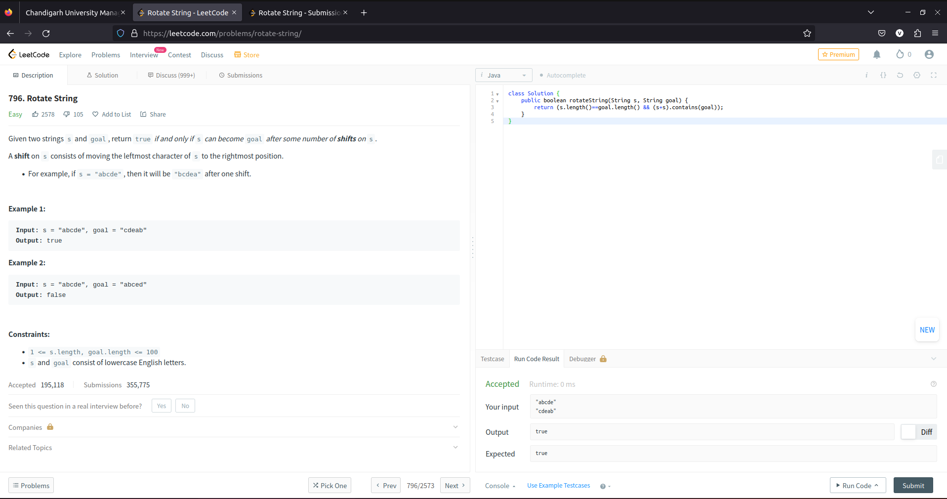**Result/Output/Writing Summary:**

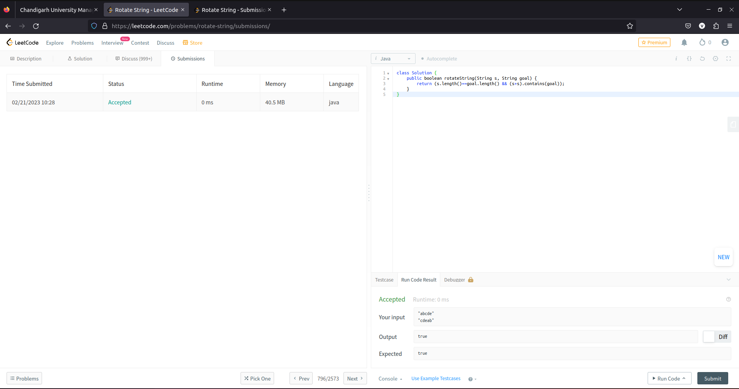

**Learning outcomes (What I have learnt):**

* + Learned the concept of String.
  + Learnt about Array in Occurance and Rotation.

**Evaluation Grid (To be created per the faculty's SOP and Assessment guidelines):**

|  |  |  |  |
| --- | --- | --- | --- |
| Sr. No. | Parameters | Marks Obtained | Maximum Marks |
| 1. | Worksheet completion including writing learning objectives/Outcomes.  (To be submitted at the end of the day). |  |  |
| 2. | Post-Lab Quiz Result. |  |  |
| 3. | Student Engagement in  Simulation/Demonstration/Performance and Controls/Pre-Lab Questions. |  |  |
|  | Signature of Faculty (with Date): | Total Marks Obtained: |  |